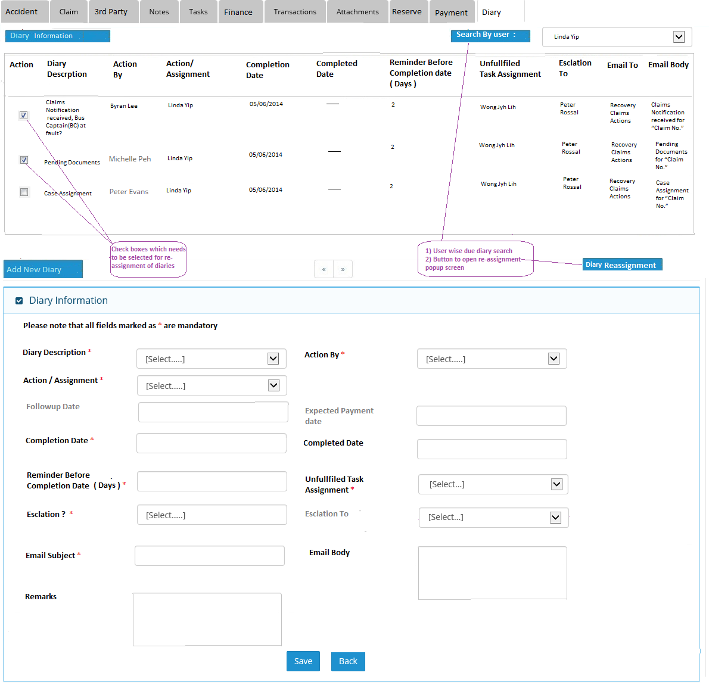

Pl include Claim # column

Note : After clicking on “Diary Re-assignment” button , following screen will be popup , by which user can reassign selected diaries.

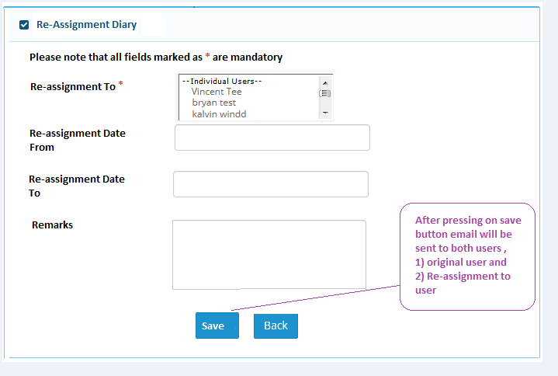

Email list all re-assigned tasks

3. system will auto re-assign back to original owner at end of re-assignment date of all outstanding re-assigned tasks. Email send to both parties, email body list all re-assigned tasks.

Mandatory field

Mandatory field